Transactional Interface Testing

Interface image:

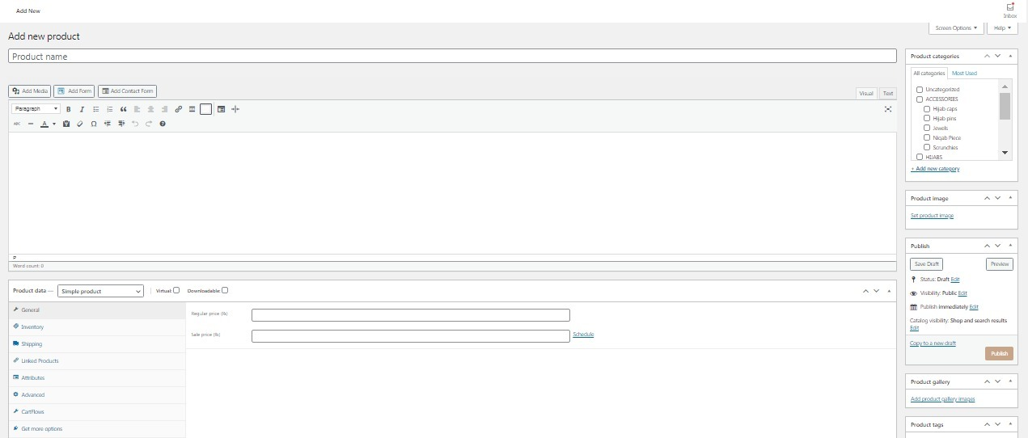

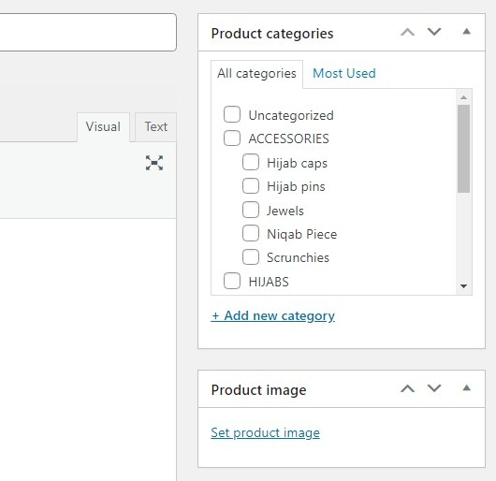

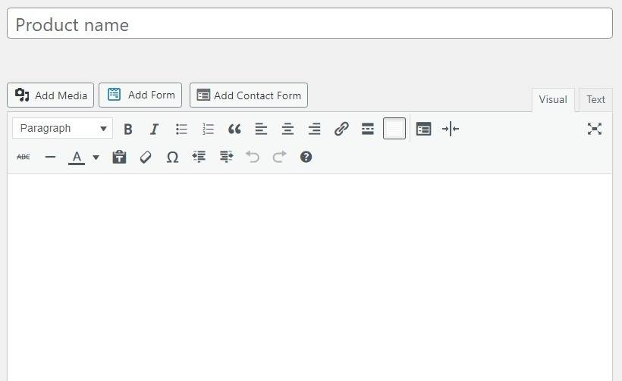

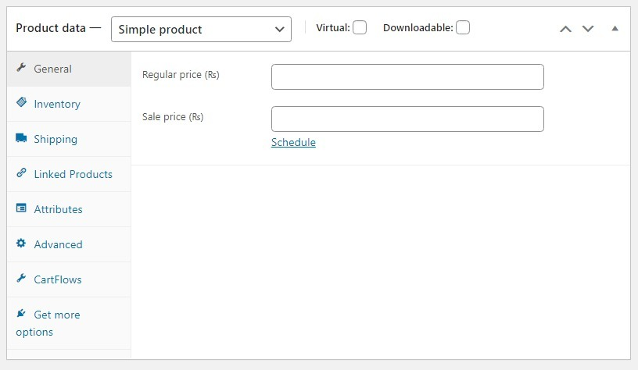

|  |  |  |  |  |  |  |  |
| --- | --- | --- | --- | --- | --- | --- | --- |
| Controls | Control type | Datatype | Valid 1 | Valid 2 | Valid 3 | Valid 4 | I use test case of (filename) |
| Product Name | Textbox | Char | Chiffon | Linen | Cotton | Lawn | 17B-010-SE MADIHA SHUJAAT |
| Product Category | Checkbox | Char | Crimp | Jewls | Caps | Chiffon | 17B-031-SE Komal Tahir Checkbox |
| Product Image | Image Selector | .jpeg .png | Jpeg | Png | --- | --- | 17B-023-SE Zubair Shahid Image Box Control |
| menstock | Checkbox | Char | Check | Uncheck | ---- | ---- | 17B-031-SE Komal Tahir Checkbox |
| Text Input Type | Dropdown list | String (str) | Heading 5 | Heading 2 | Heading 1 | Heading 6 | 17B-034-SE Muhammad Aamir Dropdown List Box.docx |
| Product | Dropdown list | Striing (str) | Simple product | Variable product | Grouped product | External/Affiliated product | 17B-034-SE Muhammad Aamir Dropdown List Box.docx |
| Manage stock | Checkboc | Char | Check | Uncheck | --- | --- | 17B-031-SE Komal Tahir Checkbox |
|  |  |  |  |  |  |  |  |

**Textbox:**

Purpose:

Textboxes are text fields that enable the user to enter some text. The user can also display or edit a text or numeric value. Its purpose is to take input from the user. It is graphical control unit. A text box is a rectangle of any size with a border that separates the text box from the rest of the interface. By clicking on textbox, a cursor is displayed so that you can begin typing. It is common for the mouse cursor to change its shape when it hovers over a text box. We can enter any type of text, it can be numeric, alphanumeric or alphabetic.

Testcase:

* Input Based:

1. Alphanumeric:
   * + 1. Does that Use blank and non-blank data?
       2. Does that include lowest and highest values?
       3. Does that include invalid characters & symbols?
       4. Does that include valid characters?
       5. Does that Include data items with first position blank?
       6. Does that Include data items with last position blank?
       7. Does that Include data with alphabets and numbers?
2. Alphabetic:
   * + 1. Does the text field allow input more than the textbox?
       2. Does the text field allow input less than the specified textbox?
       3. Does the textbox accept numbers only?
       4. Does the textbox accept decimal numbers?
       5. Does the textbox accept formatted numbers?
       6. Does the textbox accept alphabets?
       7. Does the textbox accept uppercase alphabets?
       8. Does the textbox accept lowercase alphabets?
       9. Does the textbox accept mix of upper and lowercase alphabets?
       10. Is there any specific character that field allows?
       11. Is there any specific character that field does not allow?
       12. Does the field accept HTML characters?
       13. Does the text field accept java script?

|  |  |  |  |
| --- | --- | --- | --- |
| Test Case | Input | Output | Status |
| Blank and non-blank | (Zahra Shah) Use Blank | Required fields are not acceptable | Invalid |
| Blank and non-blank | Non-Blank data | Required fields are acceptable | Valid |
| Value check | Lowest and Highest Value checking | Textbox will have no affect | Valid |
| Character and Symbol | Invalid character and symbols | Textboxes populated | Invalid |
| Character size limit | ([Zahra.993@outlook.com](mailto:Zahra.993@outlook.com)) valid character | Textboxes get populated if the size of character is in limit and are correct for the textboxes conditions | Valid |
| Fist position | Data Item – first position | Accepted | Valid |
| Last position | Data Item – last position | Rejected | Invalid |
| Alphanumeric | Zahra123 | Accepted | Valid |

ALPHABETIC:

|  |  |  |  |
| --- | --- | --- | --- |
|  | Input | Output | Status |
| Limit exceed | Zahraazamshah1234567 | Textboxes exceeds the character of limit prescribed | Invalid |
| Limit range | Zahra Shah | Textboxes get populated if the size of character is in limit | Valid |
| Numbers | 12345 | Accepted | Valid |
| Decimal | .00154 | Accepted | Valid |
| Formatted Numbers | 558-5528-55282 | Textboxes not accepts any formatted numbers | Invalid |
| Alphabets | Zahra | Textboxes accepts alphabets | Valid |
| Upper case | ZAHRAAZAM | Accepted | Valid |
| Lower case | zahra | Accepted | Valid |
| Mix Cases | ZAhraSHah | Accepted | Valid |
| Specific character | Checking.. | Rejected | Invalid |
| Specific character | Checking.. | Rejected | Invalid |
| HTML and Js | [www.outlook.com](http://www.outlook.com) | Accepted | Valid |

* Step Based:

1. Does Moving the Mouse Cursor over all Enterable Text Boxes. Do Cursor change from arrow to insert Bar.

Guidelines:

* Does the cursor appear while typing the content?
* Does the RED asterisk for mandatory fields?
* Do mandatory textbox fields show error on refreshing windows after saving it?

**Checkbox:**

Purpose:

A checkbox (check box, tick box) is a GUI widget that permits the user to make a binary choice, i.e., a choice between one of two possible mutually exclusive options. For example, the user may have to answer 'yes' (checked) or 'no' (not checked) on a simple yes/no question.

Testcase:

* Input Based (Not Found):
* Step Based:

1. Do check if the checkbox is selectable or not.
2. Do check if the checkbox selection enables the specific element as selected by mouse pointer or keyboard selection.
3. Do check if the multiple checkboxes can be selected or not.
4. Do uncheck one checkbox and select another and click on submit and verify if different choice is considered in redirection.
5. Do check enable and disabled property of the control.
6. Do check Tab sequence select checkbox control in series.
7. Does mouse click change property of checkbox from checked to unchecked or vice versa?
8. Does space bar key press from keyboard change property of checkbox from checked to unchecked or vice versa?
9. Does disabled checkbox not be editable?
10. Does Enter key press from keyboard change property of checkbox from checked to unchecked or vice versa?

|  |  |  |  |
| --- | --- | --- | --- |
| Test case | Input | Output | Status |
| Check if the checkbox is selectable or not. | Check the selected box |  | valid |
| Check if the checkbox selection enables the specific element as selected by mouse pointer or keyboard selection. | Check the box |  | Valid |
| Check if the multiple checkboxes can be selected or not. | Check more than one selected checkbox. |  | Valid |
| uncheck one checkbox and select another and click on submit and verify if different choice is considered in redirection | Uncheck the box and verify by selecting different choices |  | Valid |
| check enable and disabled property of the control | User press the enable or disable property of control | When user press it shows the properties of control | Valid |
| check Tab sequence should select checkbox control in series. | User checks tab sequence | It selects checkbox control in series | Valid |

Guidelines:

* Do verify if the selection control is inactive when the page is loaded.
* Do verify if the initial focus of the checkbox is on the first checkbox.
* Do verify if the checkboxes are placed in an order.
* Do verify the physical location of the checkboxes.
* Do verify appropriate events associated with checkbox property change.
* Does alignment is proper with other controls in window?
* Does Control should be selected and checked or unchecked event takes place when ALT + underlined character pressed from keyboard of the appropriate checkbox?

**Image Selector:**

Purpose:

The image box control is used to display graphics, to act as a container for other controls, and to display output from graphics methods or text using the Print method. The picture box control can display picture files in any of the following formats: bitmap, cursor, icon, metafile, enhanced metafile, or as JPEG or GIF files.

Testcases:

* Input Based:

1. Does it check image upload functionality with image files of different extensions (For Example, JPEG, PNG, BMP, etc.)
2. Does it check duplicate name image upload?
3. Does it check image upload with image size greater than the max allowed size. The Proper error message should be displayed?
4. Does it check if images of specified height and width (if defined) are accepted otherwise rejected?
5. Does the image upload progress bar should appear for large size images?

|  |  |  |  |  |
| --- | --- | --- | --- | --- |
| **S.no** | **Test Case Name** | **Input** | **Output** | **Status** |
| 1 | different extensions | Checking image upload extensions pdf format | Error: Select either jpeg or png file. | Invalid |
| 1 | different extensions | Checking image upload extensions jpg format | Upload successfully | Valid |
| 2 | duplicate name image upload | Checking duplicate name image upload  Enter name already exist | Error: try uploading a jpeg or png format | Invalid |
| 2 | duplicate name image upload | Checking duplicate name image upload  Enter name new name | Upload successfully | Valid |
| 3 | image size greater than the max allowed size | Checking image size greater  2048kb | Error: The image is too large | Invalid |
| 3 | image size greater than the max allowed size | Checking image size greater  1000kb | Accepted | Valid |
| 4 | specified height and width | Checking specified height and width  960 x 720 | Rejected | Invalid |
| 4 | specified height and width | Checking specified height and width  190 x 200 | Added successfully. | Valid |
| 5 | Image upload progress bar | Checking progress bar for large size image |  | Valid |

* Step Based (Not Found):

Guidelines:

* Does multiple associated images on the same page grouped as one object?
* Do check the image text wrapping style “In Line with Text “used for all images?
* Do all images, grouped images and non-text elements that convey information have alternative text descriptions?
* Do check complex images (i.e., charts and graphs) have descriptive text immediately after the image?
* Do check multiple images upload functionality?
* Do Check image quality after upload? Image quality should not be changed after upload.

**Checkbox:**

Purpose:

A checkbox (check box, tick box) is a GUI widget that permits the user to make a binary choice, i.e., a choice between one of two possible mutually exclusive options. For example, the user may have to answer 'yes' (checked) or 'no' (not checked) on a simple yes/no question.

Testcase:

* Input Based (Not Found):
* Step Based:

1. Do check if the checkbox is selectable or not.
2. Do check if the checkbox selection enables the specific element as selected by mouse pointer or keyboard selection.
3. Do check if the multiple checkboxes can be selected or not.
4. Do uncheck one checkbox and select another and click on submit and verify if different choice is considered in redirection.
5. Do check enable and disabled property of the control.
6. Do check Tab sequence select checkbox control in series.
7. Does mouse click change property of checkbox from checked to unchecked or vice versa?
8. Does space bar key press from keyboard change property of checkbox from checked to unchecked or vice versa?

Does disabled checkbox not be editable?

Test cases for Menstock:

|  |  |  |  |
| --- | --- | --- | --- |
| Test case | Input | Output | Status |
| Check if the checkbox is selectable or not. | Check the selected box |  | valid |
| Check if the checkbox selection enables the specific element as selected by mouse pointer or keyboard selection. | Check the box |  | Valid |
| Check if the multiple checkboxes can be selected or not. | Check more than one selected checkbox. |  | Valid |
| check enable and disabled property of the control | User press the enable or disable property of control | When user press it shows the properties of control | Valid |
| check Tab sequence should select checkbox control in series. | User checks tab sequence | It selects checkbox control in series | Valid |
|  |  |  |  |

Guidelines:

* Do verify if the selection control is inactive when the page is loaded.
* Do verify if the initial focus of the checkbox is on the first checkbox.
* Do verify if the checkboxes are placed in an order.
* Do verify the physical location of the checkboxes.
* Do verify appropriate events associated with checkbox property change.
* Does alignment is proper with other controls in window?
* Does Control should be selected and checked or unchecked event takes place when ALT + underlined character pressed from keyboard of the appropriate checkbox?

**DROPDOWN LIST:**

**According to Text Input Type:**

* **We have dropdown list option in which we can select any option in list by clicking it.**

|  |  |  |  |
| --- | --- | --- | --- |
| **TEST CASE** | **INPUT** | **OUTPUT** | **STATUS** |
| Choose option by clicking | Click on Heading 5. | Heading 5 selected | Valid |

* **Deselect the selected option and select another.**

|  |  |  |  |
| --- | --- | --- | --- |
| **TEST CASE** | **INPUT** | **OUTPUT** | **STATUS** |
| Deselect the selected option and choose another | Again click on Heading 5 to deselect it and then click on Heading 1. | Heading 5 deselect and Heading 1 selected in replacement of Heading 5. | Valid |

* **Presentation of data:**

|  |  |  |  |
| --- | --- | --- | --- |
| **TEST CASE** | **INPUT** | **OUTPUT** | **STATUS** |
| Display data | Open options list | It will show options available to choose. | Valid |

* **Presentation of data:**

|  |  |  |  |
| --- | --- | --- | --- |
| **TEST CASE** | **INPUT** | **OUTPUT** | **STATUS** |
| Display data | Open options list | It will show only those options which are programmable. | Invalid |

**According to Product Type:**

* **We have dropdown list option in which we can select any option in list by clicking it.**

|  |  |  |  |
| --- | --- | --- | --- |
| **TEST CASE** | **INPUT** | **OUTPUT** | **STATUS** |
| Choose option by clicking | Click on Simple product | Simple product selected | Valid |

* **Deselect the selected option and select another.**

|  |  |  |  |
| --- | --- | --- | --- |
| **TEST CASE** | **INPUT** | **OUTPUT** | **STATUS** |
| Deselect the selected option and choose another | Again click on simple product to deselect it and then click on variable product. | Simple product deselect and variable product selected in replacement of simple product. | Valid |

* **Presentation of data:**

|  |  |  |  |
| --- | --- | --- | --- |
| **TEST CASE** | **INPUT** | **OUTPUT** | **STATUS** |
| Display data | Open options list | It will show options available to choose. | Valid |

* **Presentation of data:**

|  |  |  |  |
| --- | --- | --- | --- |
| **TEST CASE** | **INPUT** | **OUTPUT** | **STATUS** |
| Display data | Open options list | It will show only those options which are programmable. | Invalid |

**GUIDELINES:**

**DROPDOWN LIST:**

**ACCORDING TO INPUT TEXT TYPE:**

* Do check for appropriate sign displayed (as arrow) over control.
* Do check for default value that should be displayed or it should be BLANK.
* Do check if list contains number of values then “Scroll” option should display and it should be working.
* Do check for “TEXT” identifier displayed with the control.
* Do check after clicking on arrow image should display as clicked.
* Does all the dropdowns on this screen sorted correctly? Alphabetic sorting is the default unless otherwise specified.
* Do ensure that the names are not abbreviations / cut short.
* Does that the drop-down accommodates the longest text within its boundary.
* Does that the drop-down can be scrolled down on clicking the down arrow.
* Does that the default text type is getting displayed when the user first visits the page.
* Does that on clicking the down arrow all text type are getting listed in its expected order.
* Does the spelling, font and style of the text inside the drop-down.
* Does that on clicking the text type, the page displays the corresponding text type.
* Does that the selected category is getting highlighted on selecting the text type.
* Does the time taking in loading the products under each text category? Too much time should not be taken for loading the text type.
* If the selection in this drop-down is controlling some other control (say, enabling/disabling etc) then check the proper action.
* Does the user is able to select the text type by pressing the down key on the keyboard.

**ACCORDING TO PRODUCT TYPE:**

* Do check for appropriate sign displayed (as arrow) over control.
* Do check for default value that should be displayed or it should be BLANK.
* Do check if list contains number of values then “Scroll” option should display and it should be working.
* Do check for “TEXT” identifier displayed with the control.
* Do check after clicking on arrow image should display as clicked.
* Does all the dropdowns on this screen sorted correctly? Alphabetic sorting is the default unless otherwise specified.
* Do ensure that the names are not abbreviations / cut short.
* Does that the drop-down accommodates the longest text within its boundary.
* Does that the drop-down can be scrolled down on clicking the down arrow.
* Does that the default product is getting displayed when the user first visits the page.
* Does that on clicking the down arrow all products are getting listed in its expected order.
* Does the spelling, font and style of the text inside the drop-down.
* Does that on clicking the product type, the page displays the corresponding products.
* Does that the selected category is getting highlighted on selecting the products.
* Does the time taking in loading the products under each product category? Too much time should not be taken for loading the products.
* If the selection in this drop-down is controlling some other control (say, enabling/disabling etc) then check the proper action.
* Does the user is able to select the products by pressing the down key on the keyboard.

**Interface:**

|  |  |
| --- | --- |
| **Testcases** | **I use testcases of (filename)** |
| Aesthetic Conditions | 17B-063-SE Usaid Alam Aesthetic Conditions |
| Validation Conditions | AsmaKhan_17B-052-SE_Validation Conditions |
| Navigation Conditions | 17B-040-SE(A)-Muhammad Immaduddin Navigation |
| Data Manipulation Operation Conditions | 17B-034-SE Muhammad Aamir Data Manipulation Operations |
| Usability Conditions | 17B-002-SE Faraz Yar Khan - Usability Conditions |
| Feedback | 17B-022-SE Ibad hashmi Feedback |
| Data Integrity Conditions | 17B-028-SE Aliza Siddiqui Data Integrity Conditions |
| Modes (Editable Read-Only) Conditions | 16B-001-SE - Mansoor Masood - Modes (Read-only, Editable) |
| General Conditions | 17B-049-SE Hassan Ahmed Siddiqui General Conditions |
| Context | Not Available |
| External Interface | Not Available |
| Internal Interface | 17B-010-SE Madiha Shujaat |
| Connection Speed | 17B-030-SE Hassan Moin |
| Browser Setting and Compatibility | 17B-026-SE M Umair Zafar |
| E-Commerce | Not Available |
| Cookies | 17B-044-SE Riffat Siddique |
| Security | 17B-047-SE Saba Hayat Khan |

**Aesthetic Conditions:**

Purpose:

The tester while testing for aesthetic conditions could use this checklist to check for mobile UI because, the purpose of aesthetic condition is use to validate screen, where we check the alignments, fonts, sizes, and colors along with the look of any controls with its respective background.

Testcases:

* Input Based (not found):
* Step Based:

1. Does it show responsiveness after zooming in and zoom out?

Zoomed Out: 

Zoomed in:

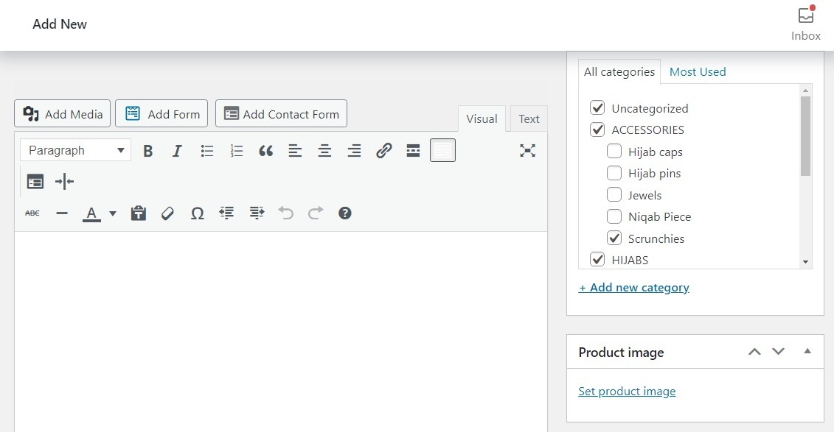

1. Does the screen orients in both portrait and landscape mode?

Landscape:

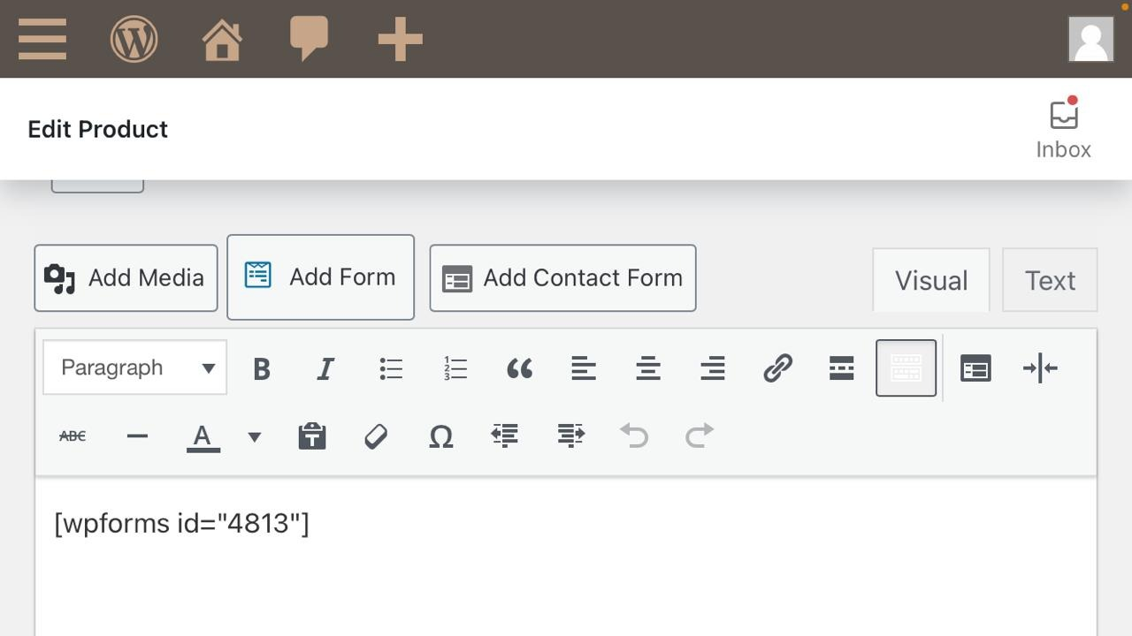

Portrait:

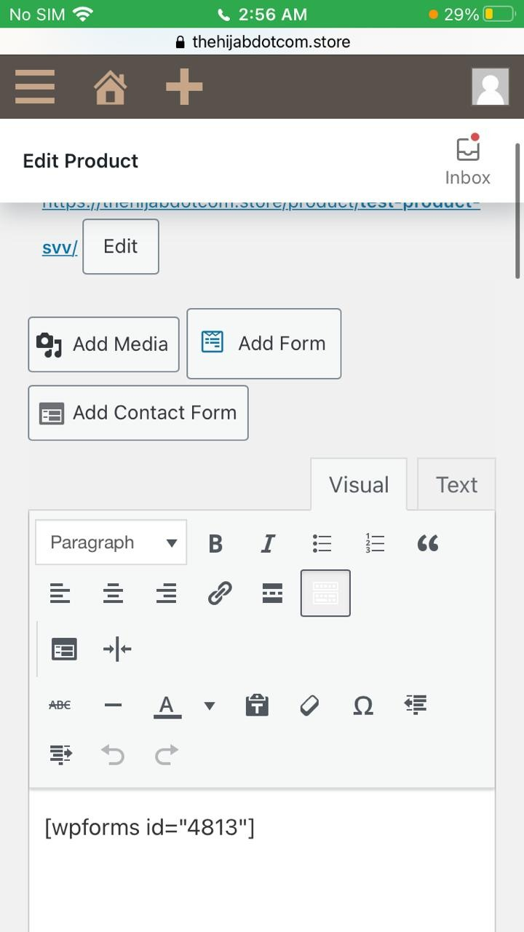

Guidelines:

* Does the color of background correct?
* Does the application fits in all resolution?

**Validation Conditions:**

Purpose:

Validation is an auto checked by the computer to make sure that the data entered by the user is correct. The purpose of it is to assess the transaction that is being implemented. Entered data is validated to ensure that the product fulfills the requirements that are demanded by the user.

Testcases:

* Input Based (not found):

1. Do you support copy & paste into the field?

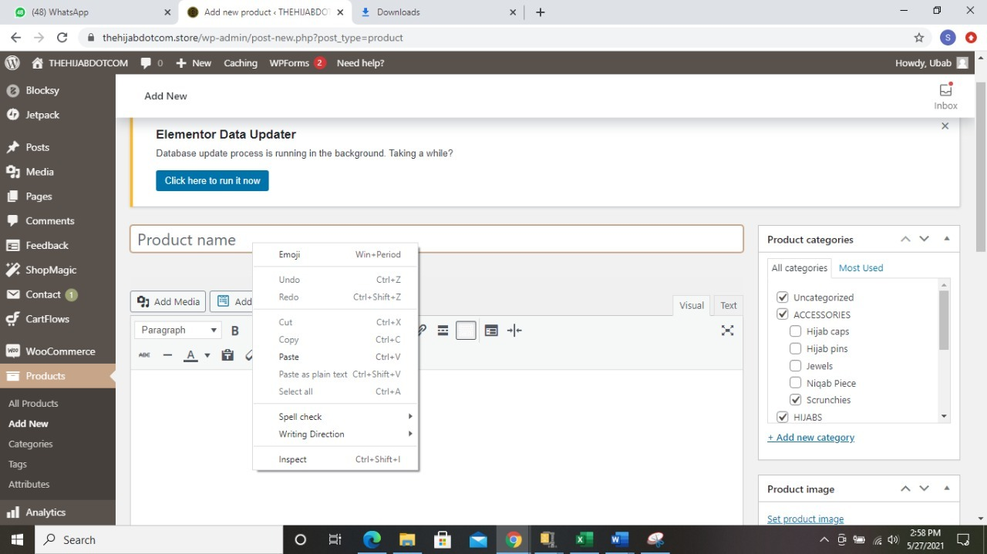

1. Do you allow typos or abbreviations?

Typos are indicated with red underline.

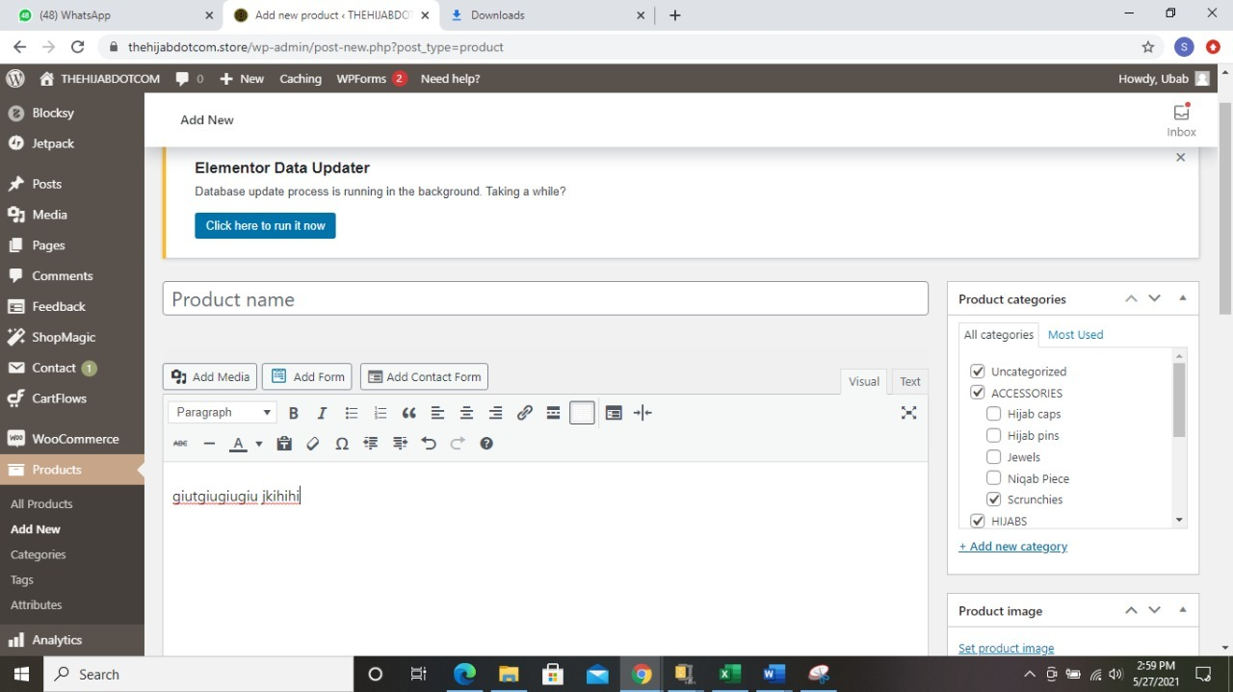

Abbreviation:

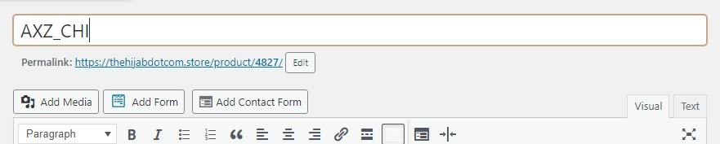

1. Do you enable different border styles?

No border styles are allowed.

* Step Based:

1. Do the field is big enough so that most possible field values are visible?

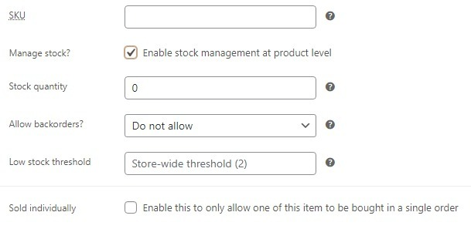

Guidelines:

* Do the label above it? (Not inside, not below)
* Do this is field necessary?
* Do the field have all the required options?
* Do the field marked as required (*) or optional?
* Does the field have enough information?

**Navigation Conditions:**

Purpose:

The purpose of data Navigation is to travel or in webpage context its moving from one page to another or in the radio button context it will be transferring from on page of app to another or it can be used as data input operator. Effective data navigations procedures usually are handled not completely independently from the procedures of initial data collection.

Testcases:

* Input Based (not found):
* Step Based:

1. Does the screen be accessed correctly from the menu?

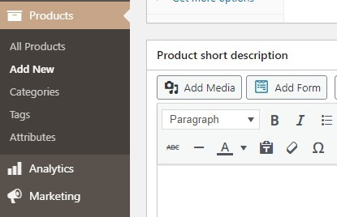

1. Does your navigation bar have proper responsiveness?

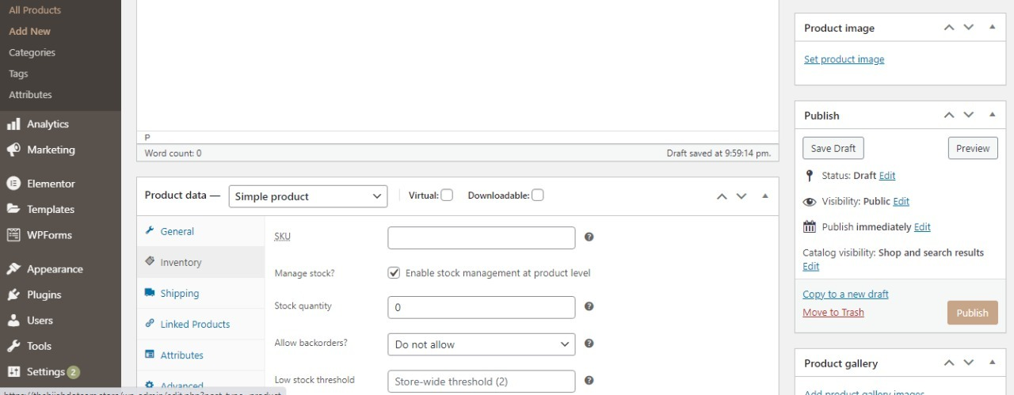

1. Does the application successfully start and exits?

Start: (starting page at dashboard)

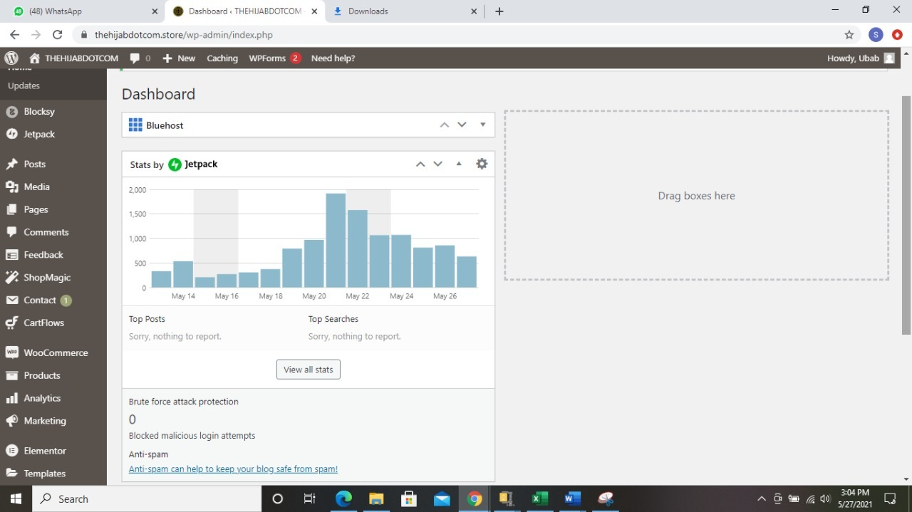

Exits: (when the product has been updated)

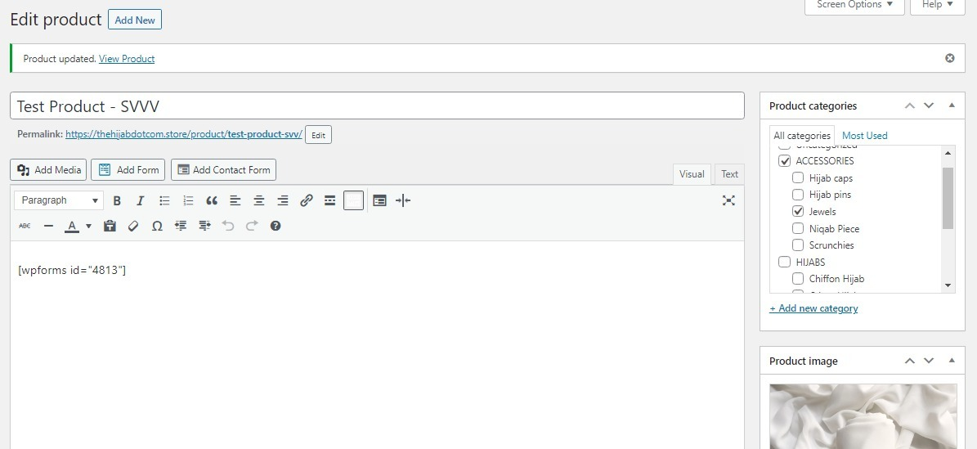

Guidelines:

* Does your navigation bar consist of your application name?
* Does your navigation bar have proper readable content?
* Does your navigation bar consist of proper color scheme and is it visible?

**Data Manipulation Operation Conditions:**

Purpose:

The purpose of manipulation operations is inserting data into database tables, retrieving existing data, deleting data from existing tables and modifying existing data.

Testcases:

* Input Based:

1. After the update do the data is still safe.

**Yes data Is saved after the update.**

1. Does the data save online (in cloud) if user click the save button?

**All the data is saved in the Cloud.**

* Step Based:

1. Do you remain logged in when the app is not in use? If not, how does that affect the user experience?
2. Does the app or websites support social authentication methods?

Guidelines:

* Does the Edited data successfully update in the database?
* Does complete data is visible.
* Does the data validated before committed to the database?
* Does the database data limits are synchronized with the front-end application?
* Does its shows error on invalid data?
* Do the user have been authorized to read insert update delete the data.
* Does image need to be cropped.
* Does image displayed after selecting image from the disk.
* Does controls enable or disable after selecting a particular case.
* Does it provide feedback after validation fail?
* Does it return the data filled form after the validation fail?
* Does it provide feedback on successful transaction?
* Does it show progress bar while posting the data to the server.
* Does it change the data in other drop-down list that is depended on the selection of current drop-down list?
* Does it support printing the data?
* Does the print’s view is adjustable for different paper sizes?
* Does it generate the pdf report for the data?

**Usability Conditions:**

Purpose:

A usability conditions helps to ensure that the users meet their desired goals effectively and efficiently, Usability conditions determine if the interface is easy to use or not also if the system is error tolerant or not.

Testcases:

* Input Based (not found):
* Step Based:

1. Does the button clicked performs the required function.

It is tested that all button perform required function.

Guidelines:

* Does the buttons and key are of user-friendly size.
* Do zoom in and out facilities work as expected.
* Does the button that have same function are of same color.
* Does the buttons are placed in the same section of the screen to avoid confusion to the end users.

**Feedback:**

Purpose:

Process in which the effect or output of an action is returned to modify the next action is known as Feedback.

Testcases:

* Input Based (not found):
* Step Based (not found):

Guidelines:

* Does the feedback I am providing specific and timely?
* Do focused on facts, not character traits?
* Do their underlying reasons for their behavior?
* Does thought about the specifics around the situation?

**Data Integration Testing:**

Purpose:

The purpose of data integrity is to detect and assure that the data is secure and consistent. It can also be defined as the application integrity, to ensure that the performance is according to the standards if it is taken in context to the mobile applications. The data needs to be secure and consistent for the concern of performance, quality and standard.

Testcases:

* Input Based (not found):
* Step Based:

1. Does the sensitive information been backed up, cleaned and removed from the website?

Guidelines:

* Does the additional security software need or available?
* Does the internet access is necessary?
* Does the sensitive information is backed up?

**Modes (Editable Read-Only)**:

Purpose:

The aim of modes is to enforce rights, authorization, and functionality integrity.

Testcases:

* Input Based (not found)
* Step Based:

1. Does the click made it read only?

**Result: Application does not support editable read only mode**.

Guidelines:

* Does Data to be shown in read-only mode is defined?
* Define what screens are to be shown as read-only to which users?

**General Condition:**

Purpose:

A set of guidelines that are used to define and test many general features of the web interfaces like the navigation of the controls and performances of the apps under various conditions such as when plug in for charging does it affect the running apps or not, rights and limitations of authority of the owner and the general procedures governing the performance of the work being done by the OS or the apps running.

Testcases:

* Input Based (not found)
* Step Based:

1. Does the app limit or clean the amount of cached data?

**Yes, it Does**.

1. Does the app function as expected after refresh?

**Yes, It Does**

1. Does the app resume it is working when it gets back into network reach from outside reach of the network?

**A refresh hit must be provided to connect back to the website**

Guidelines:

* Does the app have been tested on different browsers?
* Does the name of App show that it is self-explanatory?
* Does it have the most common gestures used to control the app?

**Context (Not Found):**

**External (Internal Interface):**

**Internal Interface:**

Purpose:

A connection to a device inside the computers cabinet and is used to achieve a complex task from which the user gets satisfied.

Testcases:

* Input Based:

1. Do we can configure the internal interface?

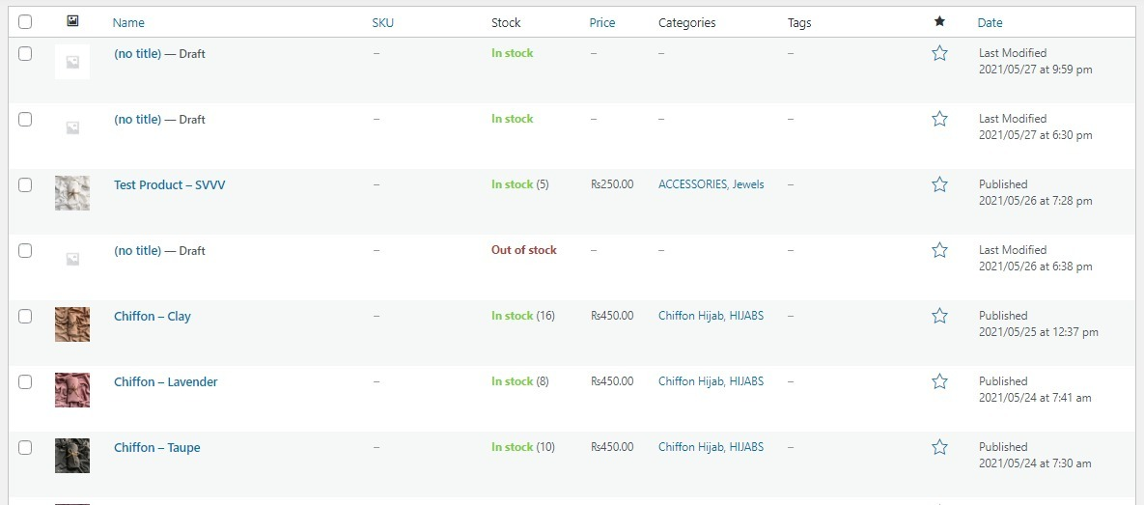

1. Do we can configure the reflexive access list for an internal interface?

No we don’t, it is done automatically.

* Step Based:

1. Does the changing of internal interface will affect the traffic message?

Yes the entire message and its formation depends upon the internal interface is it is disturbed the message changes on the front end as well.

Guidelines:

* Do we handle error problem?
* Does all communication between the servers are implemented properly?
* Does our explanation handle browser crashes?

**Connection Speed:**

Purpose:

The purpose of connection speed is to check the maximum no of users accessing a website and how load is balanced among them and the no of users is not affecting the connection speed of the web application. In connection speed we also determine the behaviors of web app under peak and normal load

* **Input Based (Not Found):**
* **Step Based:**

1. Does many users use it at same time if yes than how many?
   * **The hosting plan is currently efficient to accommodate an audience of 2500 at once as per the payment plan and offered specifications**
2. Does it check Website application response times at different connection speeds?
   * **Yes it does, the response time of website is improved eventually by service provider to make it fast and efficient**
3. Do load your web application to determine its behavior under normal and peak loads?
   * **It may show a “Cannot Connect to data base” if the path has been disturbed to server**

Guidelines:

* Does it tests over various networks?
* Does it manage no of users per time?
* Does it checks for peak loads?
* Does this support fault tolerance when error occurs?
* Does it gives response times of the users?

**Browser Setting & Compatibility:**

Purpose:

It is becoming increasingly popular for attackers to compromise computers through vulnerable web browsers. An insecure web browser can lead to spyware being installed on your computer without your knowledge, attackers taking control of your computer, stealing your information, or even using your computer to attack other computers.

Testcases:

* Input Based:

1. Does browser allow to add account to Sync data?



1. Does name and picture can be added?

The image is automatically imported from the email provided at the time od registration were as the name can be change later.

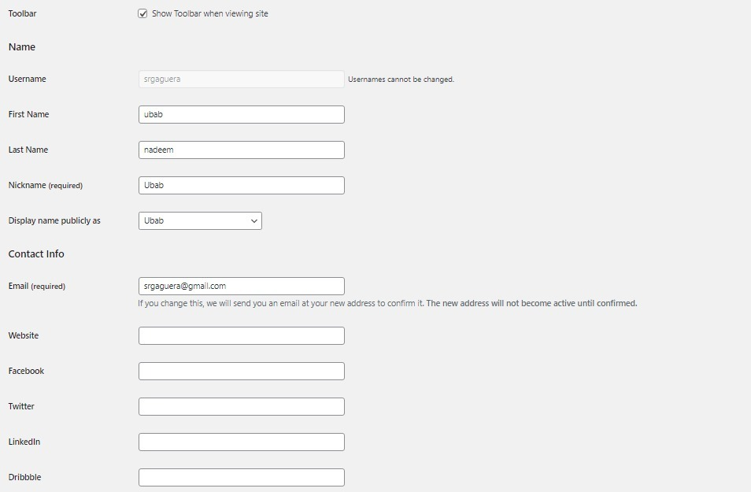

* Step Based:

1. Do the passwords fill auto?

**Passwords are automatically generated and email with an account activation link. The** **password can be changed later by user.**

1. Does the payment method fill auto?

**Yes, the payment method is set to cash on delivery by default.**

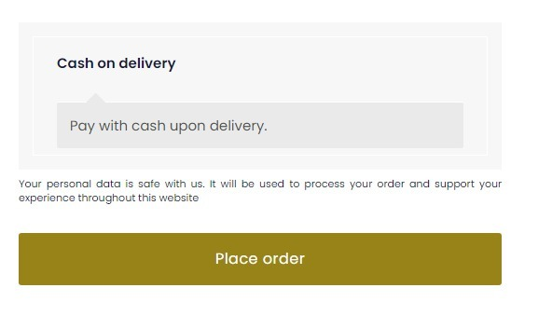

1. Does the address fill auto?

**If the account has been logged in and an order atleast has been placed from this account, Address details are automatically associated with the address**

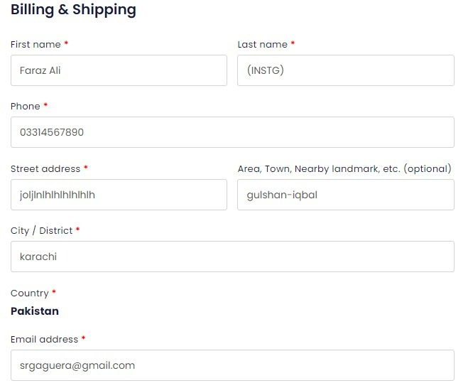

1. Does it block cookies?

**No cookies are not blocked**



Guidelines:

* Does it easy for user to access browser settings?
* Does it provide menu bar?
* Does it provide search bar?
* Does it provide subcategories?

**E-Commerce (Not Found):**

**Cookies:**

Purpose:

Cookies make the interaction between users and websites faster and easier. The purpose of the cookies is to help the website keep track of your visits and activity. Many online retailers use cookies to keep track of the items in a user’s shopping cart as they explore the site. Without cookies, your shopping cart would reset to zero every time you clicked a new link on the site. Furthermore, would be very difficult for a website to allow a visitor to fill up a shopping cart or to remember the user's preferences or registration details for a future visit. That would make it difficult to buy anything online.

Testcases:

* **Input Based (Not Found):**
* **Step Based:**

1. Does information stored in cookies been verified?
   * **It is being verified via a plugin additionally installed named as cookie optimizer**
2. Does the cookie information encrypt?
   * **Yes it has been verified to encrypt efficiently**
3. Do you prevented cookies from being editable by the user?
   * **User has no access to modify cookies**
4. Do cookies store in proper directory?
   * **They store in data related to the plugin “cookie optimizer”**

Guidelines:

* Do you have enough information about the use of cookies on websites?
* Does the website need to use persistent cookies?
* Does the website you are access is trusted enough to enable cookies?
* Do the cookies being stored successfully for verified sites?
* Do you clear cookies for websites that you have finish your transaction with?
* Do the cookies write by one website is accessible by another website?
* Do the cookies being written on multiple browsers?
* Does the website response accordingly when cookies are deleted?

**Security:**

Purpose:

Application security is the process of developing, adding, and testing security features within applications to prevent security vulnerabilities against threats such as unauthorized access and modification. Security is the protection of information systems from theft or damage to the hardware, the software, and to the information on them, as well as from disruption or misdirection of the services they provide.

* **Input Based:**

1. Does your server lock out an individual who has tried to access your site multiple times with invalid login/password information?
   * **The website requests them to reset their password via email if they forgot the previous one**
2. Do verify the timeout condition, after timeout user should not able to navigate through the site?
   * **The timeout condition is set as 8 hours, after 8 hours the website requests you to login again**
3. Do Verify that system should restrict you to download the file without sign in on the system?
   * **A file can only be downloaded if the product is set as a downloadable product and only after the user has logged in**
4. Do check the valid and invalid passwords, password rules say cannot be less than 6 characters, user id and password cannot be the same etc.?

**PASSWORD CONDITIONS:**

* + **Password cannot be same as username**
  + **Password cannot be less than 8 characters in length**
  + **Password must include a numeric value, an uppercase and a lower case**
* **Step Based (Not Found):**

Guidelines:

* 17. Do keep personal information professional and limited?
* 18. Does it keeps your privacy settings on?
* 19. Do practice safe browsing?
* 20. Does your internet connection is secure?
* 21. Do be careful what you download?
* 22. Does you choose strong passwords?
* 23. Do be careful what you post?
* 24. Do be careful who you meet online?
* 25. Do keep your antivirus program up to date?